Categorising Objects Activity

Break the group into two (or more) teams. The aim of this activity is to name as many things as possible under time pressure.
Equipment: Pens (at least one per group) and supply of paper.

Part A) Letters and categories
i) Boys names beginning with A
ii) Girls names beginning with C
iii) Places beginning with the letter P
See sheets below (laminated, in resource box)

Part B) Categories (name as many as possible)
i) Vegetables
ii) Alcoholic drinks
iii) Countries
iv) World leaders (past or present)
v) Fish
vi)Sports
vii) Things you’d find in the garden

Beginning with A Beginning with B

Beginning with C Beginning with ...

Vegetables Places

Flowers Alcoholic drinks

Famous singers Animals

World leaders

Things found in the ...

Girls’ Names Boys’ Names

beginning with ..... beginning with .....

Fish Garden
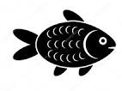

Birds
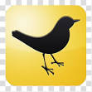
Films


Places Countries
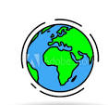
Colours Foods
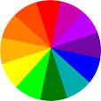

Kitchen Flowers
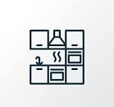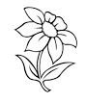

Things related to
Christmas
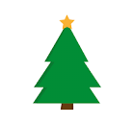

Things you enjoy


Places
beginning with ...

