What do you think of gay weddings?

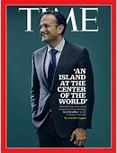

Where is your favourite place in the world?

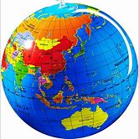

Are mobile phones a good thing?



One of Gay Byrne’s most famous interviews
What did you think of it?

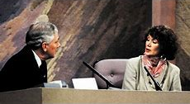

Who in the world do you admire most?

Who is the most famous person in Ireland?

Is it too easy now to get a divorce?

Where do you like to get your news from?

Do you have a favourite newspaper?

Do you have a favourite news channel on TV?

Who is your favourite news reader?

Who is your least favourite news reader?

Has anyone heard any unusual or interesting stories on the news?

