What do you think of gay weddings?

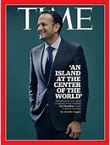

Where is your favourite place in the world?

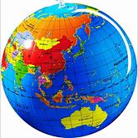

Are mobile phones a good thing?



Who in the world do you admire most?

Who is the most famous person in Ireland?

Is it too easy now to get a divorce?

One of Gay Byrne’s most famous interviews
What did you think of it?

