Food slogans/ads

Session 17
Activity
Match the products and slogans

Round 1
Heinz tomato ketchup The best things come to those who wait
Barry’s Tea Every day should have its golden moments
Lyons Extra quality, Extra flavour, _ the Quality tea
Rice Krispies Snap, crackle and pop
Pat the Baker So fresh it’s famous
Brennan’s Bread Today’s bread, today
Johnston, Mooney and O’Brien Ireland’s favourite freshly baked bread
Kilmeaden The fillet of cheddar

Round 2
McDonald’s I’m lovin’ it
Toyota The best built cars in the world
BMW The ultimate driving machine
M&M Melts in your mouth, not your hands
Flake Only the crumbliest flakiest chocolate, tastes like chocolate never tasted before
Lotto It could be you
Kit Kat Have a break, have a _ _
Heinz Baked Beans Beanz Meanz _
Round 3
Ambrosia Rice Pudding Devon knows how they make it so creamy
Red Bull Gives you wings
Guinness _ is good for you. Good things come to those who wait
Carlsberg Probably the best lager in the world
Kerrygold Pure Irish Butter
Harp lager “ And Sally O’Brien and the way she might look at you, and the pint of _ ”
Audi Vorsprung durch Technik
Nissan Innovation that excites

Match the product and its slogan
Product |  | Slogan
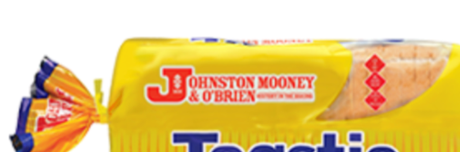 |  | The best things come to those who wait
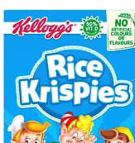 |  | So fresh it’s famous
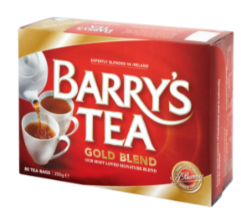 |  | The fillet of cheddar
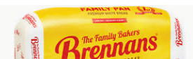 |  | Ireland’s favourite freshly baked bread
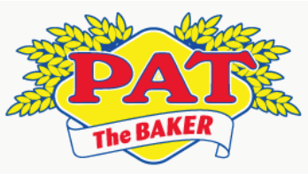 |  | Extra quality, Extra flavour,  _ the Quality tea
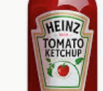 |  | Every day should have its golden moments
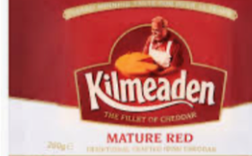 |  | Snap, crackle and pop
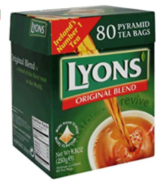 |  | Today’s bread, today
Match the product and its slogan
Product |  | Slogan
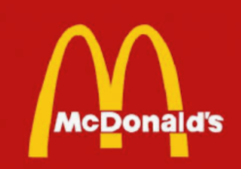 |  | Beanz Meanz _
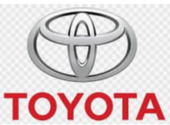 |  | Only the crumbliest flakiest chocolate, tastes like chocolate never tasted before
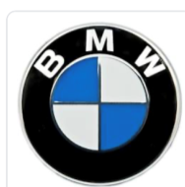 |  | The best built cars in the world
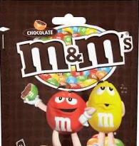 |  | I’m lovin’ it
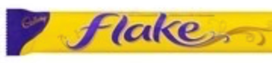 |  | Have a break, have a _ _
 |  | Melts in your mouth, not your hands
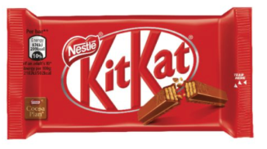 |  | The ultimate driving machine
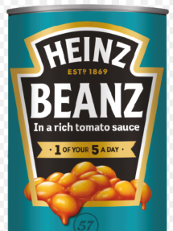 |  | It could be you
Match the product and its slogan
Product |  | Slogan
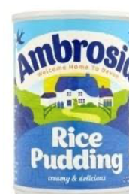 |  | Probably the best lager in the world
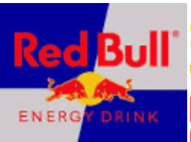 |  | Pure Irish Butter
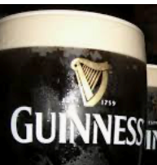 |  | Vorsprung durch Technik
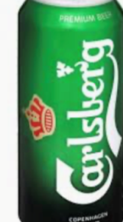 |  | Innovation that excites
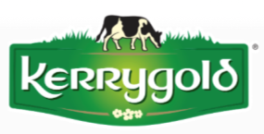 |  | Gives you wings
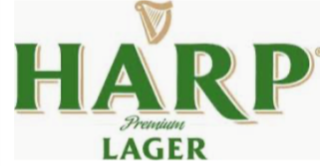 |  | Devon knows how they make it so creamy
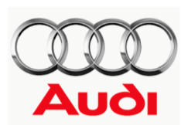 |  | “And Sally O’Brien and the way she might look at you, and the pint of _ ”
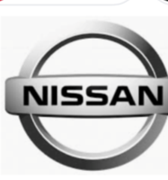 |  | _ is good for you  Good things come to those who wait

