

Supporting your Memory

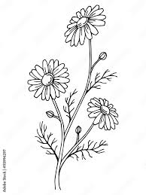



Memory Aids

- Develop systems for organising information. Create a daily, weekly and/or monthly schedule. Keep track of tasks, appointments and other events in a notebook, diary, calendar, whiteboard or electronic planner (e.g. mobile phone). It’s important that your system is kept in an easy-to-spot, uncluttered area so you can check it daily. Like anything new it may take some time to become familiar with this and it may require effort to build into your routine.

- Write things down.

- Keep a journal.

- Make use of assistive technology such as Alexa to set reminders. Most smartphones have the same ‘virtual assistants’ whom you can ask questions and arrange reminders.

- Use an alarm clock, a watch with an alarm, or a kitchen timer to remind you when you need to leave the house for an appointment, or when you have to check something cooking in the oven. Write down why you have set the alarm, so you know why it is going off. Try to keep this reminder in a place that you’re likely to notice, such as a whiteboard, calendar or diary.

- Set a recurring alarm for weekly/daily events or actions that you need/wish to engage in. This means an alarm goes off at a certain time with a message reminding you about something you need to do. This could be a one-off event like a meeting, or a regular reminder to take medication.

- Record voice notes on a phone relating to important information that can later be retrieved. Play the voice notes back later, or transfer reminders to a written calendar at the same time each day.

- Optimise the use of a routine and make associations where possible i.e. keep things in the same place, do things at the same time.

- Make use of colour codes. Try labelling keys so that each one is a different colour. Coloured rubber key caps or rings can be bought for this. For example, your front door key could be red and your garage door could be green.

- Use visual cues, e.g. pictures, the use of a white board and/or sticky notes. Use printed signs in places where you consistently need a prompt, for example place near the cooker switch to ensure cooker is turned off.

- Create mnemonics. e.g. an acronym (to be able to recall the colours of the rainbow, you could use the acronym Richard of York gave battle in vain - red, orange, yellow, green, blue, indigo and violet) or a rhyme (I before e, except after c)

- Use chunking - as the name suggests, chunking is a tool that lets us store information by breaking it down into small, easy-to-recall ‘chunks’ i.e. a phone number. Break the information down in the 4 W’s Who ? What ? Where ? When? This will condense the information and allow you to recall it easier. Make a note of anything important to you in your memory book.

- Use rhyme or alliteration. You can do this by finding a distinguishing feature and linking it to the name for e.g. Blondy Brenda.

- Use visual imagery. If you meet a lady called Rose imagine her sitting in the middle of a rose bush, or someone called Kerri imagine them in a Kerry Jersey.

- Visualise a Scenario – Imagine “seeing” the person in different situations where you may have come across them, such as bowling or having coffee.

- Make lists e.g. shopping or to-do lists. You can save a ‘favourites’ list when you shop online, making it easier to reorder each time.

- Use Google Maps on the mobile phone when leaving the house. This can also be useful if you drive or you can place a sticky note on the dash board of your car to remind you where you’re going.

- The use of locator devices may also be helpful to help find frequently mislaid items such as keys or a wallet. You attach a small electronic tag to the item. If you mislay it, you click a button on the locator device to make the tag beep. You will need to keep the locator device somewhere obvious. Further information regarding such devices can be obtained from the Memory Technology Resource Room (086 7809989).

- The use of a prompt can be useful when it is known that a particular piece of information is likely to be needed in the future. Those working/living closely with you may choose to commence relaying information to you by saying, for example, “this is important…”

- Minimise distractions and interference.

- Engage in one task at a time and take your time doing tasks.

- Take a pause during the day. The use of mindfulness exercises, e.g. deep diagrammatic breathing, or grounding exercises may be helpful in this regard.

- Optimise connection with others.

- Keep active an engaged. Exercise for 30 minutes a day.

- Keep your space clutter free.

- Ensure you get adequate sleep to optimise your attention and working memory. Aim for 7-8 hours of sleep per night and develop a nightly routine that promotes relaxation.
  - Avoid caffeine and alcohol close to bedtime.
  - Ensure a quiet dark bedroom.
  - Regular routine of going to bed and waking up.
  - Relaxation techniques (use apps or YouTube for guided relaxation exercises)

- Make use of bumpon stickers, which are coloured and raised stickers you can add to something you want to standout and identify, for example on the volume button of the remote control.

- When attending important appointments it is advisable to:
- Attend at a time in the day that he feels most alert, before tiredness sets in.
- Invite a trusted person to accompany him or should that not be practical, attend with note-taking/ recording equipment.

29. Make new learning part of your everyday life no matter how old you are.

MIND Diet

The MIND diet stands for the Mediterranean-DASH Intervention for Neurodegenerative Delay. The MIND diet aims to reduce dementia and the decline in brain health that often occurs as people age. It combines aspects of two well-researched diets, the Mediterranean Diet and Dietary Approaches to Stop Hypertension (DASH).
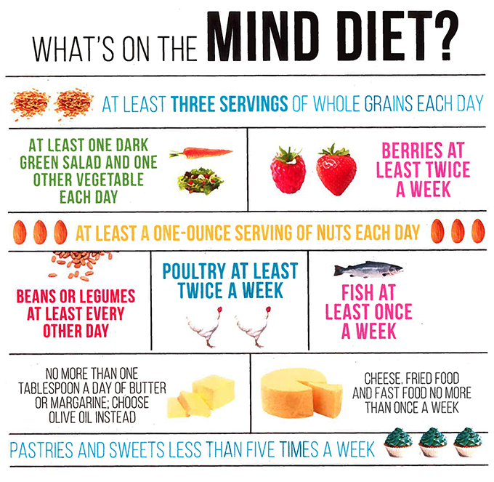

- Eat foods that boost blood flow (such as beets and cayenne pepper).
- Eat an anti-inflammatory diet, increase your intake of dietary omega-3 fatty acids with fatty fish (such as salmon or anchovies).
- Avoid toxic exposure and support the 4 organs of detoxification:
  - Kidneys – drink more water
  - Gut – eat more fiber and choose organic foods
  - Liver – quit smoking and drugs, limit alcohol, eat brassicas (such as cabbage, broccoli, cauliflower, and Brussels sprouts)
  - Skin – sweat with exercise
  - Boost your vitamin D intake and eat onions, mushrooms, and garlic.

Resources

Books:

- ‘100 Days to a Younger Brain: Maximise your memory, boost your brain health and defy dementia’ by Dr. Sabina Brennan (2022)
- ‘Stay sharp with the mind doctor’ by Ian Robertson
- A collection of 25 books on the subject have been compiled by librarians and are now available in 330 libraries nationwide. Visit your local library to see the collection.

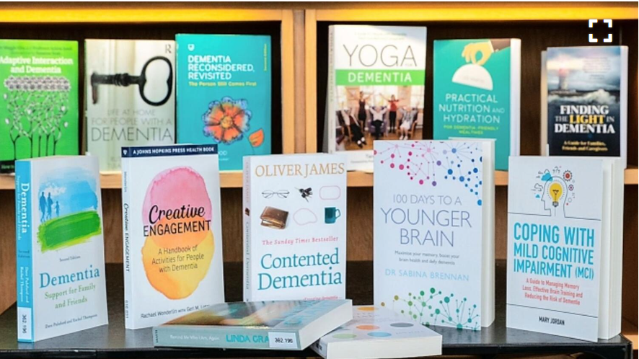

Printable Calendar:
- https://print-a-calendar.com/

Associations:
- Alzheimer’s Society of Ireland: https://alzheimer.ie/

Websites:

- Dementia Services Information and Development Centre: https://dementia.ie/

- For an introduction to mindfulness meditation that you can practice on your own, download the UCLA Mindful App or visit https://www.uclahealth.org/programs/uclamindful/free-guided-meditations/guided-meditations

- Watch a short demo video to demonstrate an Amazon Alexa (most features are similar across all brands): https://www.youtube.com/watch?v=YylOKY74Lvo&feature=youtu.be

- Minding Your Memory Videos –These short videos include topics such as how your memory works, attention, driving, and practical strategies. You can find these videos on the Cork and Kerry Community Healthcare You Tube channel: https://youtu.be/XnARJUAzjmw

- Free Dem Films – These animated films were created by Sabina Brennan of Trinity College and Trinity Brain Health. They provide public awareness around important issues of memory and brain health. The engaging films cover topics such as How Does Memory Work, Why is Attention Important, and What Can You Do to Keep Your Brain Healthy. You can find these videos at the FreeDem Living website: http://freedemliving.com/

- The following website has some useful resources available and more information on Assistive Technologies: www.southtipperarydementia.ie
Memory Technology Resource Room: 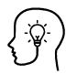
- Memory Technology Resource Rooms (MTRRs) showcase a wide range of assistive technologies (AT) and supports for people with memory problems, with the aim of helping people to maintain their independence and improve their quality of life.
There are currently 27 MTRRs around the country managed by a healthcare professional, most commonly an Occupational Therapist. The MTRRs provide a service to people with dementia and other memory problems, their families and carers, and are a resource for healthcare personnel and voluntary agencies.
- To find out more about a Memory Technology Resource Room in your area please visit https://www.understandtogether.ie/getsupport/memory-technology-resource-rooms/memory-technology-resourcerooms.html

