What has been your best holiday?

What is your favourite drink?

What is your favourite time of year?

How many were in your family growing up?

What is your favourite food?

Where were you born?

Where is your favourite hotel?

Where in the world would you most like to visit?

?

What is your favourite colour?

What was your

first job?

What was your first car?

Who has been Ireland’s best President?

What is your favourite newspaper?

Where have you lived?

What is your favourite hobby?

Who was the best Late Late Show host?

What is your favourite television programme?

What is your favourite radio station?

Who was the best

Late Late Show host?

Ryan Tubridy, Gay Byrne
or Pat Kenny?

?
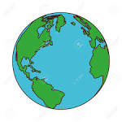

Which of these places

would you most like to visit?

France, Africa, China or Alaska



Health is better than wealth
Money is the root of all evil!
Do you agree?

Should children be given pocket money?

What’s your opinion on betting and gambling?

